Avicom JAVR.

A comprehensive range of all Weather and Vandal proof Telephones.

JAVR101-FK Weatherproof Telephone, Full keypad, Yellow
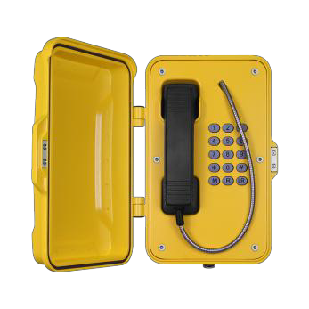
Housed in a weatherproof cast aluminum enclosure, IP66~IP67 Order Code
- JAVR101-FK (Analog model)
- JAVR101-FK-SIP (SIP/VoIP model)
- JAVR101-FK-GSM (GSM model)
- JAVR101-FK-3G (3G model)

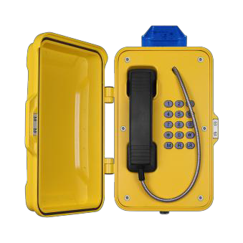
JAVR101-FK-L Weatherproof Telephone, Full Keypad, Yellow, with LED lamp fixed on the top, Wall-Mounting
Housed in a weatherproof cast aluminum enclosure, IP66~IP67

Order Code
- JAVR101-FK-L (Analog model)
- JAVR101-FK-L-SIP (SIP/VoIP model)
- JAVR101-FK-L-GSM (GSM model)
- JAVR101-FK-L-3G (3G model)

JAVR101-CB Weatherproof Telephone, CB (hot line), Yellow
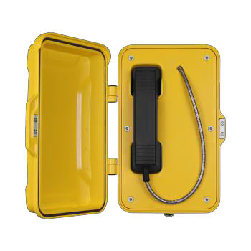
Housed in a weatherproof cast aluminum enclosure, IP66~IP67 Order Code
- JAVR101-CB (Analog model)
- JAVR101-CB-SIP (SIP/VoIP model)
- JAVR101-CB-GSM (GSM model)
- JAVR101-CB-3G (3G model)

JAVR101-CB-L Weatherproof Telephone, Hotline Phone, Yellow, with LED Lamp
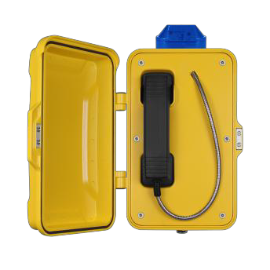
Housed in a weatherproof cast aluminum enclosure, IP66~IP67 Order Code
- JAVR101-CB-L (Analog model)
- JAVR101-CB-L-SIP (SIP/VoIP model)
- JAVR101-CB-L-GSM (GSM model)
- JAVR101-CB-L-3G (3G model)

JAVR101-3B Weatherproof Telephone, 3 buttons for speed dial, Yellow
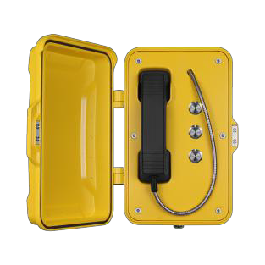
Housed in a weatherproof cast aluminum enclosure, IP66~IP67 Order Code
- JAVR101-3B (Analog model)
- JAVR101-3B-SIP (SIP/VoIP model)
- JAVR101-3B-GSM (GSM model)
- JAVR101-3B-3G (3G model)

JAVR102-SC Weatherproof Telephone, Speed dial, Yellow
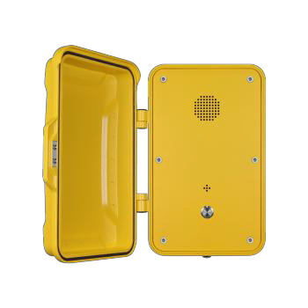
Housed in a weatherproof cast aluminum enclosure, IP66~IP67 Order Code
- JAVR102-SC (Analog model)
- JAVR102-SC-SIP (SIP/VoIP model)
- JAVR102-SC-GSM (GSM model)
- JAVR102-SC-3G (3G model)

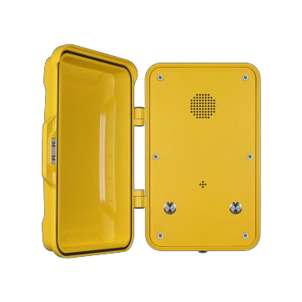
JAVR 102-2B Weatherproof Telephone, 2 buttons for speed dial, Yellow Housed in a weatherproof cast aluminum enclosure, IP66~IP67 Order Code
- JAVR102-2B (Analog model)
- JAVR102-2B-SIP (SIP/VoIP model)
- JAVR102-2B-GSM (GSM model)
- JAVR102-2B-3G (3G model)

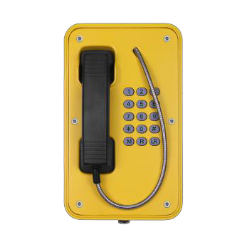
JAVR103-FK Weatherproof Telephone, Full keypad, Yellow, without door Housed in a weatherproof cast aluminum enclosure, IP66 Order Code
- JAVR103-FK (Analog model)
- JAVR103-FK-SIP (SIP/VoIP model)
- JAVR103-FK-GSM (GSM model)
- JAVR103-FK-3G (3G model)

JAVR103-CB Weatherproof Telephone, CB (hot line), Yellow, Without door
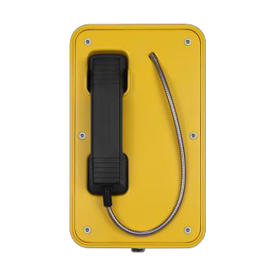
Housed in a weatherproof cast aluminum enclosure, IP66 Order Code
- JAVR103-CB (Analog model)
- JAVR103-CB-SIP (SIP/VoIP model)
- JAVR103-CB-GSM (GSM model)
- JAVR103-CB-3G (3G model)

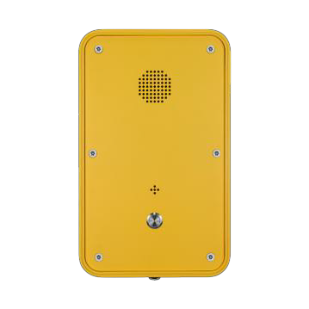
JAVR104-SC Weatherproof Telephone, Speed dial, Yellow, without door Housed in a weatherproof cast aluminum enclosure, IP66 Order Code
- JAVR104-SC (Analog model)
- JAVR104-SC-SIP (SIP/VoIP model)
- JAVR104-SC-GSM (GSM model)
- JAVR104-SC-3G (3G model)

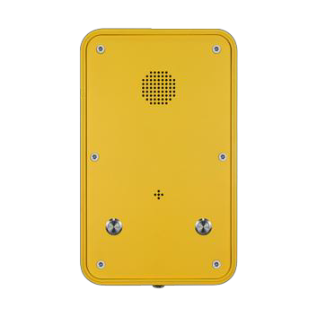
JAVR104-2B Weatherproof Telephone, 2 buttons for speed dial, Yellow, without door Housed in a weatherproof cast aluminum enclosure, IP66
Order Code
- JAVR104-2B (Analog model)
- JAVR104-2B-SIP (SIP/VoIP model)
- JAVR104-2B-GSM (GSM model)
- JAVR104-2B-3G (3G model)

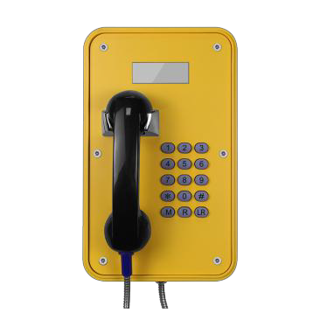
JAVR105-FK Weatherproof Telephone, Full keypad, Yellow, With LCD display Housed in a weatherproof cast aluminum enclosure, IP66~IP67 Order Code
- JAVR105-FK (Analog model)
- JAVR105-FK-SIP (SIP/VoIP model)
- JAVR105-FK-GSM (GSM model)
- JAVR105-FK-3G (3G model)

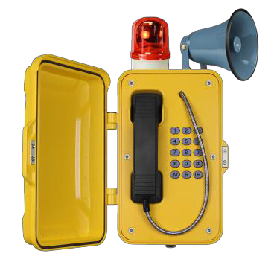
JAVR101-FK-HB Weatherproof Telephone, Full keypad, Yellow, With horn and beacon
Housed in a weatherproof cast aluminum enclosure, IP66~IP67

Order Code
- JAVR101-FK-HB (Analog model)
- JAVR101-FK-HB-SIP (SIP/VoIP model)
- JAVR101-FK-HB-GSM (GSM model)
- JAVR101-FK-HB-3G (3G model)

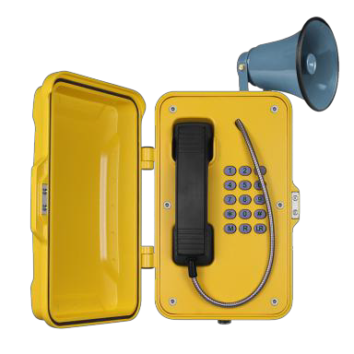
JAVR101-FK-H Weatherproof Telephone, Full keypad, Yellow, with horn Housed in a weatherproof cast aluminum enclosure, IP66~IP67 Order Code
- JAVR101-FK-H (Analog model)
- JAVR101-FK-H-SIP (SIP/VoIP model)
- JAVR101-FK-H-GSM (GSM model)
- JAVR101-FK-H-3G (3G model)

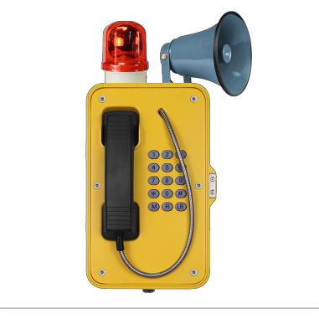
JAVR103-FK-HB Weatherproof Telephone, Full keypad, Yellow, With horn and beacon
Housed in a weatherproof cast aluminum enclosure, IP66~IP67

- JAVR103-FK-HB (Analog model)
- JAVR103-FK-HB-SIP (SIP/VoIP model)
- JAVR103-FK-HB-GSM (GSM model)
- JAVR103-FK-HB-3G (3G model)

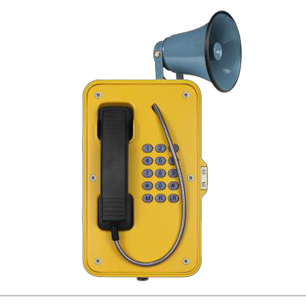
JAVR103-FK-H Weatherproof Telephone, Full keypad, Yellow, With horn

Housed in a weatherproof cast aluminum enclosure, IP66~IP67

- JAVR103-FK-H (Analog model)
- JAVR103-FK-H-SIP (SIP/VoIP model)
- JAVR103-FK-H-GSM (GSM model)
- JAVR103-FK-H-3G (3G model)

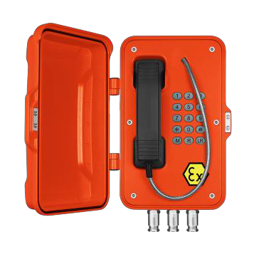
JAVR EX101 Explosion Proof Telephone, Full keypad, Orange , color(other colours on demand),with door cover
Housed in a weatherproof cast aluminum enclosure, IP66~IP67

Order Code
- JAVREX101-Analog (Analog model)
- JAVREX101-SIP (SIP/VoIP model)

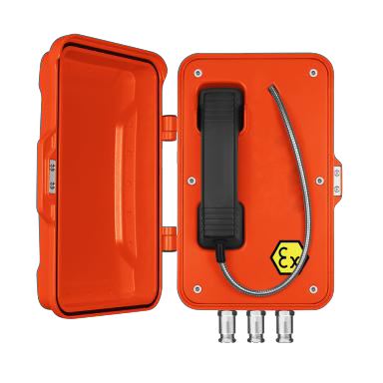
JAVR EX101-CB Explosion Proof Telephone, Hotline, Orange color (other colours on demand),with door cover
Housed in a weatherproof cast aluminum enclosure, IP66~IP67

Order Code
- JAVREX101-CB-Analog (Analog model)
- JAVREX101-CB-SIP (SIP/VoIP model)

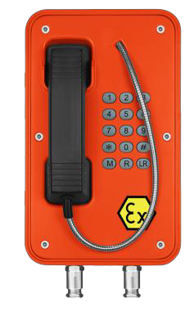
JAVRVEX103 Explosion Proof Telephone, Full keypad, Orange, color (other colours on demand),without door cover
Housed in a weatherproof cast aluminum enclosure, IP66~IP67

Order Code
- JAVREX103-Analog (Analog model)
- JAVREX103-SIP (SIP/VoIP model)

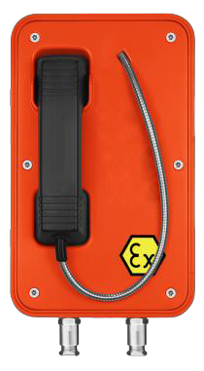
JAVR EX103-CB Explosion Proof Telephone, Hotline, Orange color (other colours on demand),without door cover
Housed in a weatherproof cast aluminum enclosure, IP66~IP67

Order Code
- JAVREX103-CB-Analog (Analog model)
- JAVREX103-CB-SIP (SIP/VoIP model)

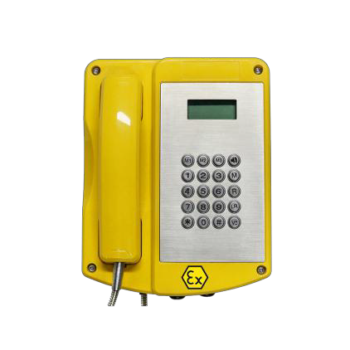
Explosion Proof Telephone, Stainless steel full keypad (20 keys), Yellow color (other colours on demand),with LCD display
JAVREX106
Housed in a weatherproof GRP (Glass fiber-reinforced polyester) enclosure, IP67 rating
Order Code
- JAVREX106-Analog (Analog model)
- JAVREX106-SIP (SIP/VoIP model)

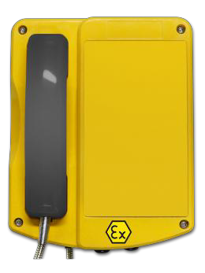
JAVREX106-CB Explosion Proof Telephone, Hotline, without keypad, Orange color(other colours on demand)
Housed in a weatherproof GRP(Glass fiber-reinforced polyester) enclosure, IP67 rating
Order Code
- JAVREX106-CB-Analog (Analog model)
- JAVREX106-CB-SIP (SIP/VoIP model)

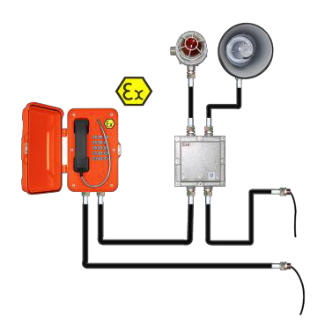
JAVR EX101-HB Explosion Proof Telephone, Full keypad, Orange color(other colours on demand),with door cover, with external Ex junction box. ,Ex Horn, Ex Beacon.
Housed in a weatherproof cast aluminum enclosure, IP66~IP67

Order Code
- JAVREX101-HB-Analog (Analog model)
- JAVREX101-HB-SIP (SIP/VoIP model)

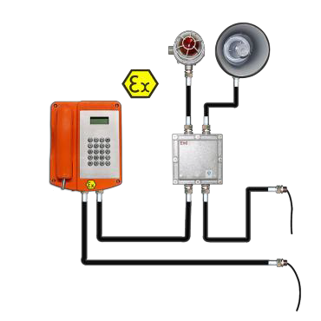
JAVR EX106-HB Explosion Proof Telephone, Stainless steel full keypad (20 keys), Orange color (other colours on demand), with LCD display
Housed in a weatherproof GRP (Glass fiber-reinforced polyester) enclosure, IP67 rating, with external Ex junction box, Ex Horn, Ex Beacon.
Order Code
- JAVREX106-HB-Analog (Analog model)
- JAVREX106-HB-SIP (SIP/VoIP model)

Handset Telephones

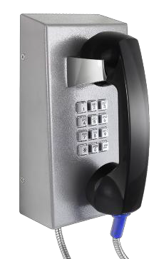
JAVR201-FK Handset Telephone, Full keypad, Gray color and optional for Yellow, Red, Blue
Housed in a anti-vandal metal enclosure, wall mounting type

Order Code
- JAVR201-FK (Analog model)
- JAVR201-FK-SIP (SIP/VoIP model)
- JAVR201-FK-GSM (GSM model)
- JAVR201-FK-3G (3G model)

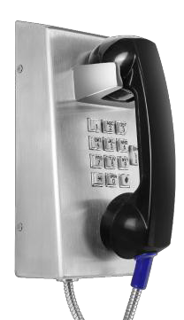
JAVR201-FK-VC Handset Telephone, Full keypad, Brushed Stainless steel body, Wall mounted type. with volume control button
Housed in a anti-vandal metal enclosure, wall mounting type

Order Code
- JAVR201-FK-VC (Analog model)
- JAVR201-FK-VC -SIP (SIP/VoIP model)
- JAVR201-FK-VC -GSM (GSM model)
- JAVR201-FK-VC -3G (3G model)

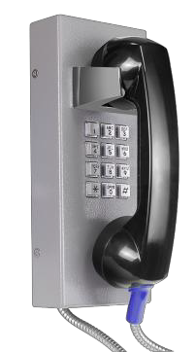
JAVR202-FK Handset Telephone, Full keypad, Gray color and optional for Yellow, Red, Blue
Housed in an anti-vandal metal enclosure, wall mounting type

Order Code
- JAVR202-FK (Analog model)
- JAVR202-FK-SIP (SIP/VoIP model)
- JAVR202-FK-GSM (GSM model)
- JAVR202-FK-3G (3G model)

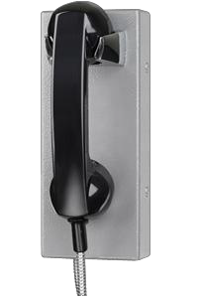
JAVR202-CB Handset Telephone, CB(Hotline), Gray, color and optional for Yellow, Red, Blue
Housed in a anti-vandal metal enclosure, wall mounting type

Order Code
- JAVR202-CB (Analog model)
- JAVR202-CB-SIP (SIP/VoIP model)
- JAVR202-CB-GSM (GSM model)
- JAVR202-CB-3G (3G model)

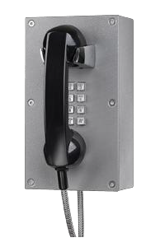
JAVR203-FK Handset Telephone, Full keypad, Gray, color and optional for Yellow, Red, Blue
Housed in a anti-vandal metal enclosure, wall mounting type

Order Code
- JAVR203-FK (Analog model)
- JAVR203-FK-SIP (SIP/VoIP model)
- JAVR203-FK-GSM (GSM model)
- JAVR203-FK-3G (3G model)

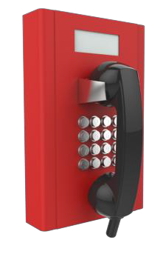
JAVR204-FK Handset Telephone, Full Keypad (16 keys), LCD display, Vandal Resistant steel body, Wall mounted type
Housed in a anti-vandal metal enclosure, wall mounting type, Red color and optional for Yellow, Blue, Gray
Order Code
- JAVR204-FK (Analog model)
- JAVR204-FK-SIP (SIP/VoIP model)
- JAVR204-FK-GSM (GSM model)
- JAVR204-FK-3G (3G model)

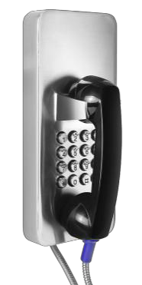
JAVR205-FK Handset Telephone, Full Keypad (16 keys), Brushed Stainless steel body, Wall mounted type
Housed in a anti-vandal metal enclosure, wall mounting type

Order Code
- JAVR205-FK (Analog model)
- JAVR205-FK -SIP (SIP/VoIP model)
- JAVR205-FK -GSM (GSM model)
- JAVR205-FK -3G (3G model)

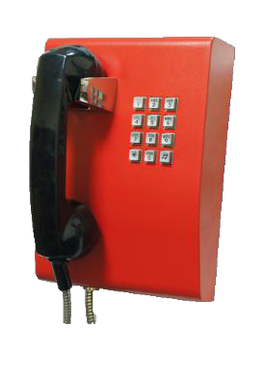
JAVR206-FK Handset Telephone, Full keypad, Red color and optional for Yellow, Gray, Blue
Housed in a anti-vandal metal enclosure, wall mounting type

Order Code
- JAVR206-FK (Analog model)
- JAVR206-FK-SIP (SIP/VoIP model)
- JAVR206-FK-GSM (GSM model)
- JAVR206-FK-3G (3G model)

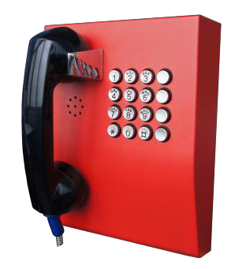
JAVR207-FK Handset Telephone, Full keypad (16 keys), Red color and optional for Yellow, Gray, Blue
Housed in a weatherproof, anti-vandal metal enclosure, designed for Wall-mounting
Order Code
- JAVR207-FK (Analog model)
- JAVR207-FK-SIP (SIP/VoIP model)
- JAVR207-FK-GSM (GSM model)
- JAVR207-FK-3G (3G model)

JAVR 208-FK Handset Telephone, Full keypad, Stainless steel body
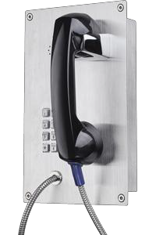
Housed in a anti-vandal metal enclosure, flush mounting type Order Code
- JAVR208-FK (Analog model)
- JAVR208-FK-SIP (SIP/VoIP model)
- JAVR208-FK-GSM (GSM model)
- JAVR208-FK -3G (3G model)

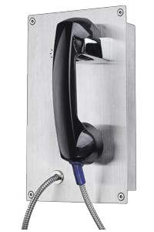
JAVR 208-CB Handset Telephone, CB (hot line), Stainless steel body Housed in a anti-vandal metal enclosure, flush mounting type Order Code
- JAVR208-CB (Analog model)
- JAVR208-CB-SIP (SIP/VoIP model)
- JAVR208-CB-GSM (GSM model)
- JAVR208-CB-3G (3G model)

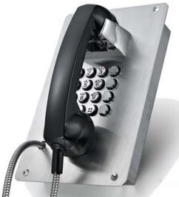
JAVR 209-FK Handset Telephone, Full keypad (16 keys), Brushed Stainless steel body, Flush mounted type
Housed in a anti-vandal brushed stainless steel enclosure, flush mounting type
Order Code
- JAVR209-FK (Analog model)
- JAVR209-FK -SIP (SIP/VoIP model)
- JAVR209-FK -GSM (GSM model)
- JAVR209-FK -3G (3G model)

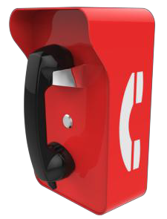
JAVR 210-1B Handset Telephone, One button for speed dial, Vandal Resistant steel body, Wall mounted type
Housed in a weatherproof, anti-vandal metal enclosure, designed for Wall-mounting
Order Code
- JAvR210-1B (Analog model)
- JAVR210-1B-SIP (SIP/VoIP model)
- JAVR210-1B-GSM (GSM model)
- JAVR210-1B-3G (3G model

JAVR 211-FK Handset Telephone, Full Keypad (12 keys), Vandal Resistant steel body, Desk mounted type.
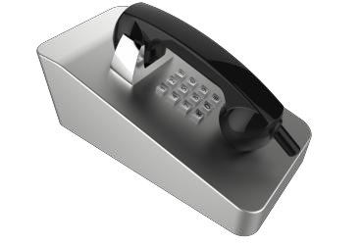
Housed in a anti-vandal brushed stainless steel enclosure, desk mounting type
Order Code
- JAVR211-FK (Analog model)
- JAVR211-FK-SIP (SIP/VoIP model)
- JAVR211-FK-GSM (GSM model)
- JAVR211-FK-3G (3G model)

JAVR 211-CB Handset Telephone, CB (hot line), Vandal Resistant steel body, Desk mounted type
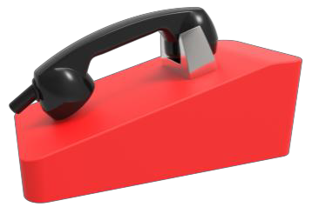
Housed in a anti-vandal metal enclosure, desk mounting type, Red color and optional for Yellow, Blue, Gray
Order Code
- JAVR211-CB (Analog model)
- JAVR211-CB -SIP (SIP/VoIP model)
- JAVR211-CB -GSM (GSM model)
- JAVR211-CB -3G (3G model)

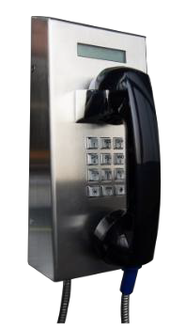
JAVR 212-FK Handset Telephone, Full keypad, Brushed Stainless steel body, Wall mounted type. With volume control button and LCD display
Housed in a anti-vandal metal enclosure, wall mounting type

Order Code
- JAVR212-FK (Analog model)
- JAVR212-FK-SIP (SIP/VoIP model)
- JAVR212-FK-GSM (GSM model)
- JAVR212-FK-3G (3G model)

Handsfree Telephones

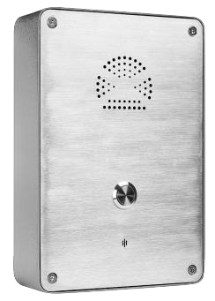
JAVR 301-SC Emergency Telephone, 1 Button, Autodial, Wall Mounting

Housed in a weatherproof, Stainless Steel enclosure, designed for Wall
-mounting Order Code
- JAVR301-SC (Analog model)
- JAVR301-SC-SIP (SIP/VoIP model)
- JAVR301-SC-GSM (GSM model)
- JAVR301-SC-3G (3G model)

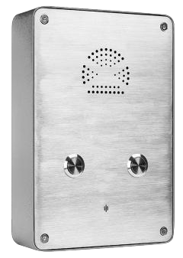
JAVR 301-2B Emergency Telephone, 2 Buttons, Autodial, Wall Mounting

Housed in a weatherproof, Stainless Steel enclosure, designed for Wall-mounting
Order Code
- JAVR301-2B (Analog model)
- JAVR301-2B-SIP (SIP/VoIP model)
- JAVR301-2B-GSM (GSM model)
- JAVR301-2B-3G (3G model)

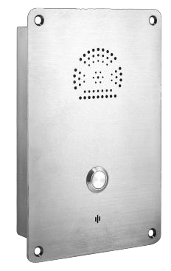
JAVR 301-SC-IW Emergency Telephone, 1Button, Autodial, Flush Mounting

Housed in a weatherproof, Stainless Steel enclosure, designed for Flush-mounting
Order Code
- JAVR301-SC-IW (Analog model)
- JAVR301-SC-IW -SIP (SIP/VoIP model)
- JAVR301-SC-IW -GSM (GSM model)
- JAVR301-SC-IW -3G (3G model)

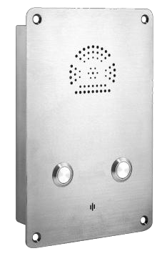
JAVR 301-2B-IW Emergency Telephone, 2 Buttons, Autodial, Flush Mounting

Housed in a weatherproof, Stainless Steel enclosure, designed for Flush
-mounting Order Code
- JAVR301-2B-IW (Analog model)
- JAVR301-2B-IW -SIP (SIP/VoIP model)
- JAVR301-2B-IW -GSM (GSM model)
- JAVR301-2B-IW -3G (3G model)

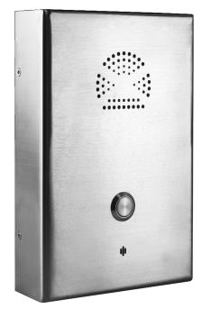
JAVR 302-SC Emergency Telephone, 1Button, Autodial, Wall Mounting

Housed in a weatherproof, Stainless Steel enclosure, designed for Wall-mounting
Order Code
- JAVR302-SC (Analog model)
- JAVR302-SC-SIP (SIP/VoIP model)
- JAVR302-SC-GSM (GSM model)
- JAVR302-SC-3G (3G model)

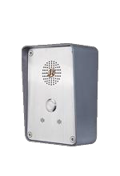
Emergency Telephone, 1 Button, Autodial, Wall Mounting
JAVR304-scSC

Housed in a weatherproof, anti-vandal metal enclosure, designed for wall-mounting
Order Code
- JAVR304-SC (Analog model)
- JR304-SC-SIP (SIP/VoIP model)
- JR304-SC-GSM (GSM model)
- JR304-SC-3G (3G model)

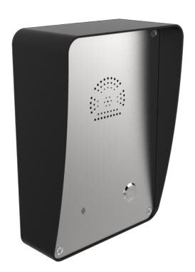
JAVR305-SC Emergency Telephone, 1 Button, Autodial, Wall Mounting

Housed in a weatherproof, anti-vandal metal enclosure, designed for wall-mounting or post mounting
Order Code
- JAVR305-SC (Analog model)
- JAVR305-SC-SIP (SIP/VoIP model)
- JAVR305-SC-GSM (GSM model)
- JAVR305-SC-3G (3G model)

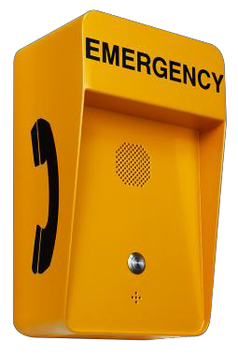
JAVR306-SC Emergency Telephone, 1 Button, Autodial, Wall Mounting

Housed in a weatherproof, anti-vandal metal enclosure, designed for wall-mounting or post mounting
Order Code
- JAVR306-SC (Analog model)
- JAVR306-SC-SIP (SIP/VoIP model)
- JAVR306-SC-GSM (GSM model)
- JAVR306-SC-3G (3G model)

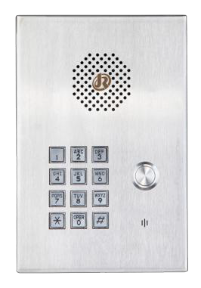
JAVR308-FK Emergency Telephone, Full keypad ,Wall Mounting

Housed in a weatherproof, Stainless Steel enclosure, designed for wall-mounting
Order Code
- JAVR308-FK (Analog model)
- JAVR308-FK-SIP (SIP/VoIP model)
- JAVR308-FK-GSM (GSM model)
- JAVR308-FK-3G (3G model)

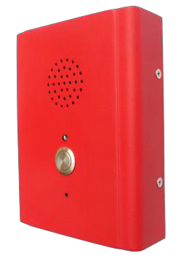
JAVR313-SC Emergency Telephone, 1 Button, Autodial, Wall Mounting, Yellow and optional for Yellow, Red, Blue.
Housed in a weatherproof, anti-vandal metal enclosure, designed for wall-mounting.
Order Code
- JAVR313-SC (Analog model)
- JAVR313-SC-SIP (SIP/VoIP model)
- JAVR313-SC-GSM (GSM model)
- JAVR313-SC-3G (3G model)

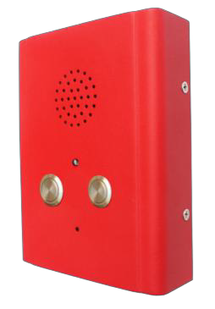
JAVR313-2B Emergency Telephone, 2 Buttons, Autodial, Wall Mounting, Red color and optional for Yellow, Blue, Gray
Housed in a weatherproof, anti-vandal metal enclosure, designed for on wall
-mounting Order Code
- JAVR313-2B (Analog model)
- JAVR313-2B -SIP (SIP/VoIP model)
- JAVR313-2B -GSM (GSM model)
- JAVR313-2B -3G (3G model)

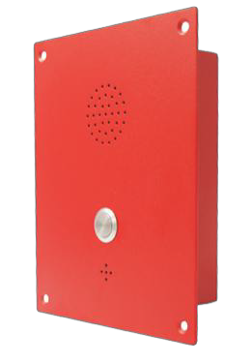
JAVR314-SC Emergency Telephone, 1 Button, Autodial, Flush Mounting, Red and optional for Yellow, Gray, Blue.
Housed in a weatherproof, anti-vandal metal enclosure, designed for flush-mounting
Order Code
- JAVR314-SC (Analog model)
- JAVR314-SC-SIP (SIP/VoIP model)
- JAVR314-SC-GSM (GSM model)
- JAVR314-SC-3G (3G model)

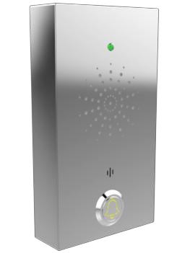
JAVR505-SC Emergency Elevator Telephone,1 Buttons, Autodial, Wall Mounting

Housed in a weatherproof, anti-vandal metal enclosure, designed for wall
-mounting Order Code
- JAVR505-SC (Analog model)
- JAVR505-SC-SIP (SIP/VoIP model)
- JAVR505-SC-GSM (GSM model)
- JAVR505-SC-3G (3G model)

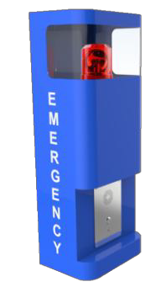
JAVR320-SC Emergency Telephone, 1Button, Autodial, with LED lamp, Blue and color optional for Red, Yellow
Housed in a weatherproof, anti-vandal metal enclosure, designed for wall-mounting or post mounting
Order Code
- JAVR320-SC (Analog model)
- JAVR320-SC-SIP (SIP/VoIP model)
- JAVR320-SC-GSM (GSM model)
- JAVR320-SC-3G (3G model)

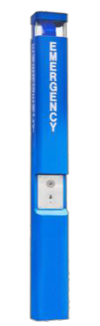
JAVR321-SC Emergency Telephone, 1Button, Autodial, Post Mounting, with lamp, Blue color
Housed in a weatherproof, anti-vandal metal enclosure, designed for Standing along-mounting
Order Code
- JAVR321-SC (Analog model)
- JAVR321-SC-SIP (SIP/VoIP model)
- JAVR321-SC-GSM (GSM model)
- JAVR321-SC-3G (3G model)

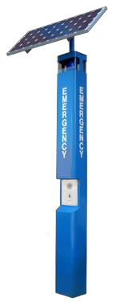
JAVR321-SC-SP Emergency Telephone, 1 Button, Autodial, Post Mounting, with lamp and solar panel, Blue color
Housed in a weatherproof, anti-vandal metal enclosure, designed for Stand along-mounting
Order Code
- JAVR321-SC-SP (Analog model)
- JAVR321-SC-SP-SIP (SIP/VoIP model)
- JAVR321-SC-SP-GSM (GSM model)
- JAVR321-SC-SP-3G (3G model)

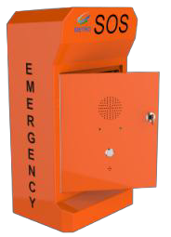
JAVR 330-SC Emergency Telephone, 1 Buttons, Autodial, Wall Mounting, Orange color, with lock key for open the door
Housed in a weatherproof, anti-vandal metal enclosure, designed for wall
–mounting or post mounting Order Code
- JAVR330-SC (Analog model)
- JAVR330-SC-SIP (SIP/VoIP model)
- JAVR330-SC-GSM (GSM model)
- JAVR330-SC-3G (3G model)

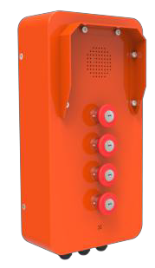
JAVR 316-4B Industrial Intercom, 4Buttons, Autodial, Column Mounting, suitable for outdoor application, Orange color
Housed in a weatherproof, anti-vandal metal enclosure, designed for Column-mounting
Order Code
- JAVR316-4B (Analog model)
- JAVR316-4B -SIP (SIP/VoIP model)
- JAVR316-4B -GSM (GSM model)
- JAVR316-4B -3G (3G model)

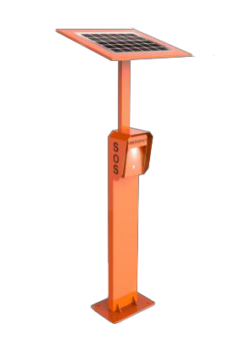
JAVR 306-SC-SP Emergency Telephone, 1Button, Autodial, Column Mounting, with LED light and solar panel, Orange color (other colours on demand)
Housed in a weatherproof, anti-vandal metal enclosure, designed for Column-mounting
Order Code
- JAVR306-SC-SP (Analog model)
- JAVR306-SC–SIP-SP (SIP/VoIP model)
- JAVR306-SC–GSM-SP (GSM model)
- JAVR306-SC-3G-SP (3G model)

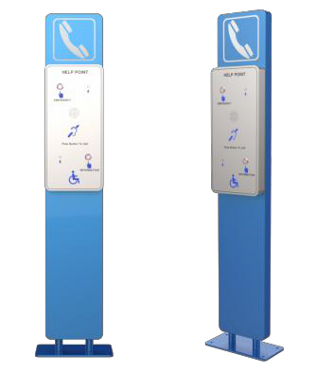
JAVR 315-SC Emergency Help Point, 2Buttons, Autodial, with built-in induction loop, Column Mounting
Housed in a weatherproof, anti-vandal brushed stainless steel enclosure, designed for Column-mounting
Order Code
- JAVR315-SC (Analog model)
- JAVR315-SC-SIP (SIP/VoIP model)
- JAVR315-SC-GSM (GSM model)
- JAVR315-SC-3G (3G model)

Emergency Telephones Pillar

JAVR-TP-01 Emergency Telephone Pillar, painted for outdoor use.
Mechanical characteristics:
Sleek and harmonious design free of sharp edges Prepared for the containment of auxiliary circuits
Material: Made of galvanized steel, painted for outdoor using. It can be manufactured in stainless steel AIS304/AIS316L on demand.
Colour: yellow (other colours on demand)
Weight:20 kg Dimensions(mm):1500 x 300x 300 mm Fixing: on floor

JAVR-TP-02 Emergency Telephone Pillar, painted for outdoor use.
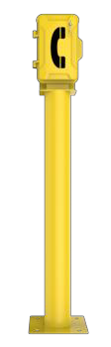
Mechanical characteristics:
Sleek and harmonious design free of sharp edges Prepared for the containment of auxiliary circuits
Material: Made of galvanized steel, It can be manufactured in stainless steel AIS304/AIS316L on demand.
Colour: yellow (other colours on demand)
Weight:25 kg Dimensions(mm):1500 x 300 x 300 mm Fixing: on floor

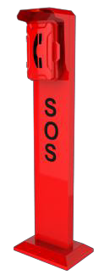
JAVR-TP-03 Emergency Telephone Pillar, painted for outdoor use. Can choose to add LED lights Mechanical characteristics:
Sleek and harmonious design free of sharp edges Prepared for the containment of auxiliary circuits
Material: Made of galvanized steel, It can be manufactured in stainless steel AIS304/AIS316L on demand
Colour :Red(other colours on demand)
Weight:30 kg Dimensions(mm):1500 x 436 x 306 mm Fixing: on floor

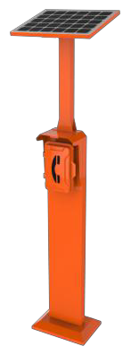
JAVR-TP-04 Emergency Telephone Pillar, painted for outdoor use.
Mechanical characteristics:
Sleek and harmonious design free of sharp edges Prepared for the containment of auxiliary circuits
With Solar panel mounting bracket which is adjustable on multiple directions Material: Made of galvanized steel, It can be manufactured in stainless steel AIS304/AIS316L on demand.
Colour: Orange (other colours on demand)
Weight:45kg Dimensions(mm):2400 x 436 x 306 mm Fixing: on floor

Telephone Hood

JAVR-TH-01 Acoustic insulation: Noise Attenuation up to 23 dB
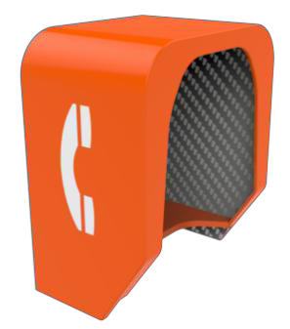
Polyethylene plastic construction
Durable, lightweight, chemical resistant body Excellent low temperatures impact properties
High performance polyurethane acoustic insulation liner, resistant to mildew and rot Fire retardant class "0" rating
Wall or pillar installation
Can be used both indoors, outdoors and offshore Optional colors available upon request
Weight: 25 kg Dimensions(mm):500 x 680x 780 mm

JAVR-TH-02 Acoustic insulation: Noise Attenuation up to 15 dB
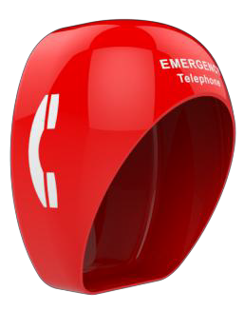
Polyethylene plastic construction
Durable, lightweight, chemical resistant body Excellent low temperatures impact properties Can be used both indoors, outdoors and offshore Wall or pillar installation
Optional colors available upon request
Weight: 20 kg Dimensions(mm):480 x 690x 800 mm

JAVR-TH-04 Acoustic insulation: Noise Attenuation up to 15 dB
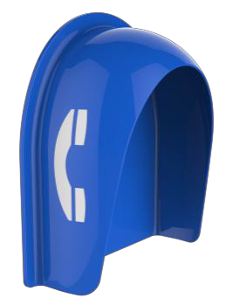
Polyethylene plastic construction
Durable, lightweight, chemical resistant body Excellent low temperatures impact properties Can be used both indoors, outdoors and offshore Wall or pillar installation
Optional colors available upon request
Weight: 18 kg Dimensions(mm):640 x 580x 260 mm

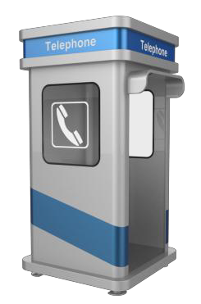
JAVR-TH-03 Standalone booth
Robust metal construction Contain an inside lamp Fancy looking and modern
Waterproof, can be used outdoors Noise reduction with door Up to 38dB
Noise reduction without door Up to 25dB
Optional colors and dimension available upon request Weight: 300 kg Dimensions(mm):1100 x 1100x 2400 mm

