MAY 2022

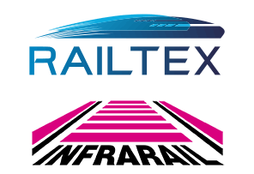
10th to 12th May 2022

TRANSIT CABLE PRODUCTS Ltd will be exhibiting with

RSCC Wire & Cable LLC - EXANE Cables

at INFRARAIL-RAILTEX 2022 at London Olympia.

Find us on the Goldwing Cable Stand C85

