NOVEMBER 2021

- Transit Cable Products Ltd will be attending The World Nuclear Exhibition 30 Nov - 2 Dec 2021 at Paris-Nord Villepinte
- You can find us at the American Pavilion with RSCC Nuclear Cables.
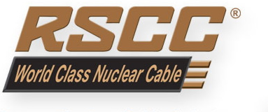
Innovative Engineered Cable Solutions
https://inbound.r-scc.com/nuclear

